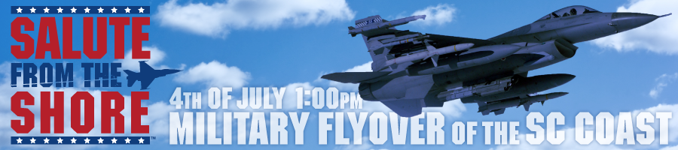
MISSION: To honor America’s armed forces and their families on the 4th of July.
VISION: To create an opportunity for South Carolina beachgoers to honor our armed forces by organizing a “Salute from the Shore” of a military flyover of the entire South Carolina coast each Independence Day. Our vision is to unite participants in a synchronized Salute to our troops that will be recorded and shared across the nation and around the world.
WHO WE ARE: We are a 501(c)3, non-profit group of patriotic South Carolinians who simply want to honor our armed forces and their families. We recognize it is because of their service and sacrifice that we are able to celebrate our freedom from the very shores they endlessly strive to protect.
WHAT IS THE SALUTE? The Salute from the Shore is a unique opportunity for individuals, friends, and families to salute our armed forces while celebrating Independence Day on South Carolina beaches. Our role, in partnership with the Town of Pawley’s Island, is to organize and promote a flyover of four F-16s on the 4th of July that will stretch the entire length of South Carolina’s coast. The 2012 flyover will be flown by the 79th Fighter Squadron, “The Flying Tigers” from Shaw Air Force Base. Interestingly, the 79th was the last U.S. military unit to leave Iraq and their heroism and valor will be celebrated by Salute from the Shore this year. We will capture as much footage of the flyover as possible - from the air and ground - to include in a video that will be posted for all to see.
WHEN IS THE SALUTE FROM THE SHORE ? The Flyover starts July 4th at 1:00 PM.
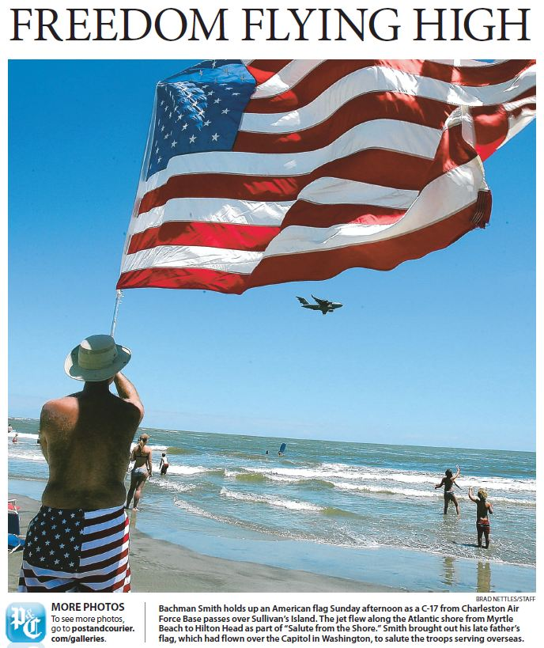WHERE IS THE SALUTE? The Salute will be visible from every beach in South Carolina. It will start at the NC state line at 1:00 and fly south, ending at Hilton Head Island at 1:29. Be sure to arrive early!
Salute from the Shore as seen from Sullivan’s Island, July 4, 2010
WE NEED YOUR HELP! Participants on the shore are encouraged to Salute the flyover by wearing and waving red, white, and blue. We’re asking participants to record themselves “Saluting” the Flyover and our troops in images and videos, and to share their stories at www.SalutefromtheShore.org and on our Facebook page. For more information, visit www.SalutefromtheShore.org.

CONTACT:
John Michael Otis, President
Salute from the Shore, Inc.
www.SaluteFromTheShore.org
jmotis@salutefromtheshore.org
803.730.9289

